Unit 6 Day 4

Think about the story City Cat, Country Cat. Which place do you like best?

I like the city. You can do many things in the city.

Read this poem, it is called Rice and Beans

I will make some soup for her. I need rice and beans.

Let’s go to the grocery store. To get rice and beans.

You get rice right there, and the beans right there.

We have rice, we have beans, everything that we need.

I will make some soup for her. I need rice and beans.

You go to the grocery store to buy food.

What foods did the boy pick up at the grocery store?

What is the boy making with the things he picked up?

Community Places:

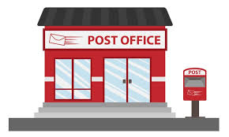

Post Office

I go to the post office

to mail my letter.

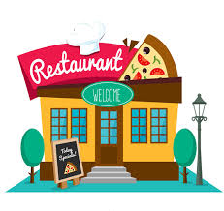

Restaurant

I eat food at a restaurant.



Library

I go to the library to

check out books to read.

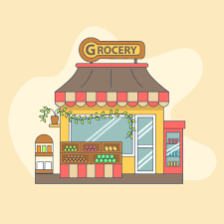

Grocery Store

I go to the grocery store

to get food to eat!

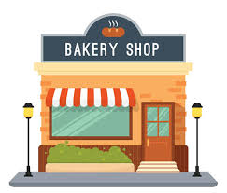

Bakery

I go to the bakery to get

fresh bread and baked goods!

Activities! You are welcome to do all of these activities but please do at least three of them.

1. Have you child choose one of the places above (post office, restaurant, library, grocery store, or bakery) and have them create their own shop!
2. Have your child write these words 3 times each – post office, restaurant, library, grocery store, and bakery.
3. Have your child draw pictures of a food they might make for another family member. Then, have them tell what they need to make the food by using the frame - *I need (list of food items) to make (the name of the meal).*
4. Have your child practice these simple sight words 5 times each (walk, run, any, give, all). This means to say the word, have the child say the word, and write the word.